--***** 1.Altering Table employees*****--

--Adding new Column "linkedin_profile"

ALTER TABLE employees

ADD COLUMN linkedin_profile VARCHAR(250);

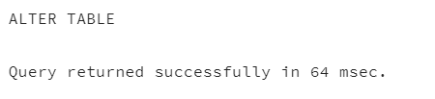select*from employees

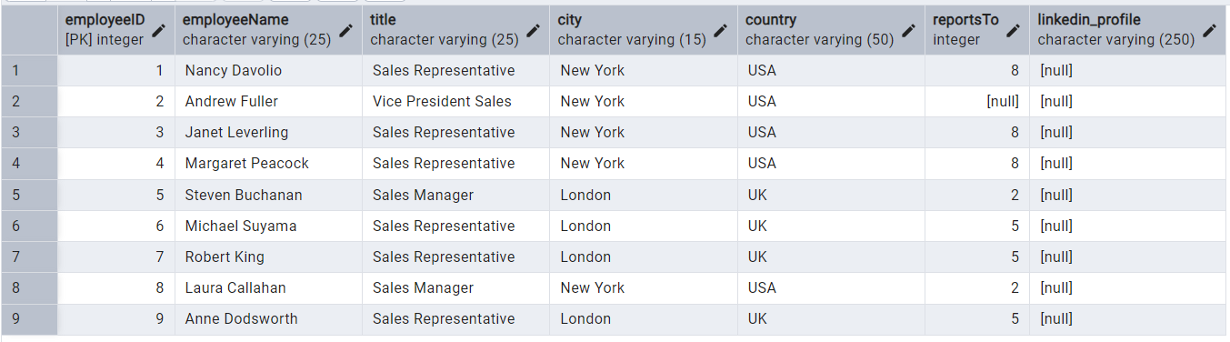

--Change the column datatype to TEXT

ALTER TABLE employees

ALTER COLUMN linkedin_profile TYPE TEXT;

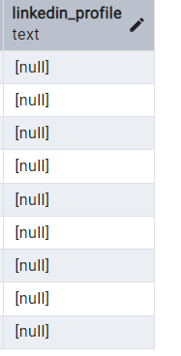

-- Add UNIQUE and NOT NULL constraints to 'linkedin_profile'

ALTER TABLE employees

ADD CONSTRAINT unique_linkedin_profile UNIQUE (linkedin_profile);

-- Ensure no NULLs before setting NOT NULL

--To attain this first we need to drop the column created and add the column

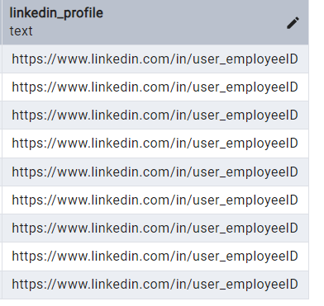ALTER TABLE employees

DROP COLUMN linkedin_profile;

ALTER TABLE employees

ADD COLUMN linkedin_profile TEXT

GENERATED ALWAYS AS ('https://www.linkedin.com/in/user_' || 'employeeID') STORED;

--Add NOT NULL constraint

ALTER TABLE employees

ALTER COLUMN linkedin_profile SET NOT NULL;

-- Drop the 'linkedin_profile' column

ALTER TABLE employees

DROP COLUMN linkedin_profile;

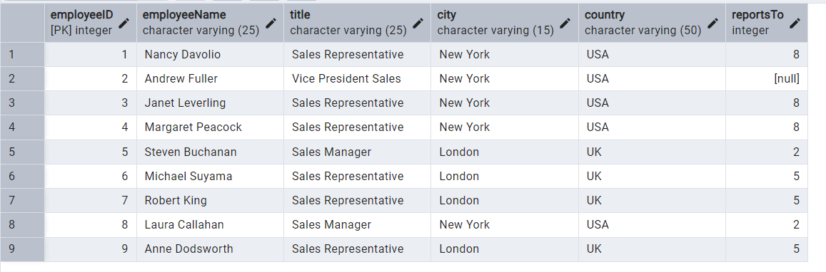=========================================================================

--****2.Querying(Select)****--

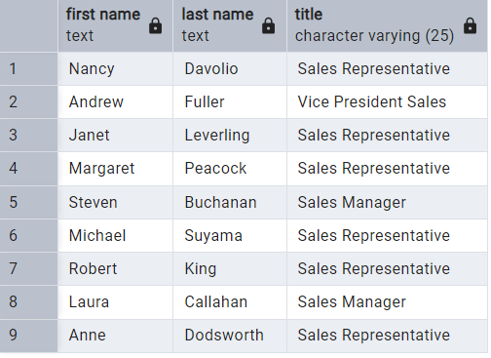-- Retrieve the first name, last name, and title of all employees--

SELECT split_part("employeeName",' ',1) AS "first name",

split_part("employeeName",' ',2) AS "last name" ,

title

FROM employees;

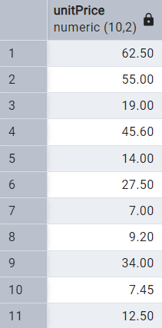--Find all unique unit prices of products--

select*from products

SELECT DISTINCT "unitPrice"

FROM products;

-- List all customers sorted by company name in ascending order--

SELECT *

FROM customers

ORDER BY "companyName" ASC;

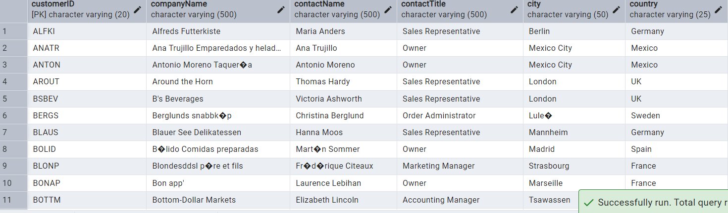

-- Display product name and unit price, but rename the unit_price column as price_in_usd--

SELECT "productName", "unitPrice" AS price_in_usd

FROM products;

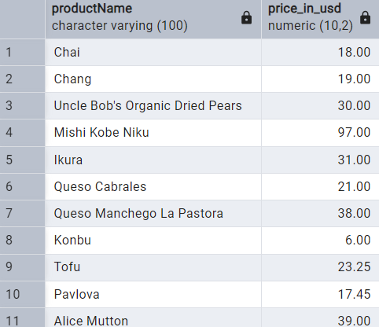

--****3.Filtering****--

--Get all customers from Germany--

select *

FROM customers

WHERE country ='Germany'

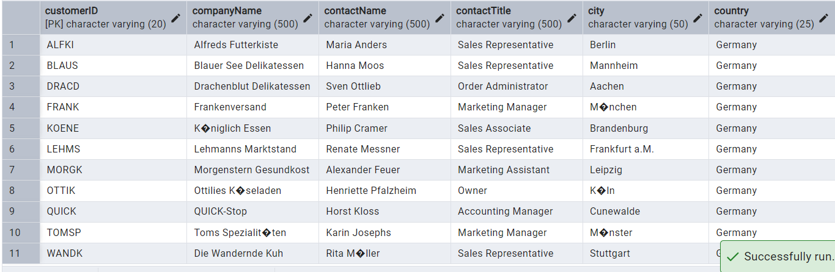

--Find all customers from France or Spain--

SELECT *

FROM customers

WHERE country IN ('France', 'Spain');

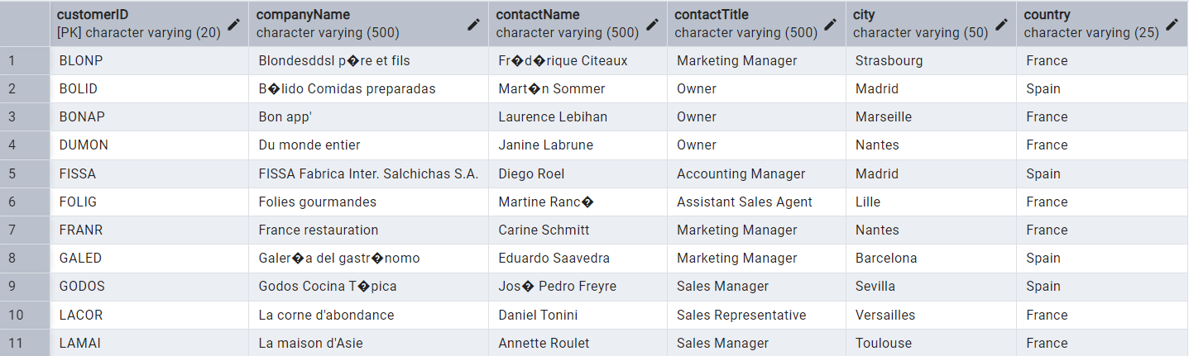

--Retrieve all orders placed in 2014, and either have freight >50,or a non-Null shipped date--

SELECT *

FROM orders

WHERE EXTRACT(YEAR FROM "orderDate") = 2014

AND (freight > 50 OR "shippedDate" IS NOT NULL);

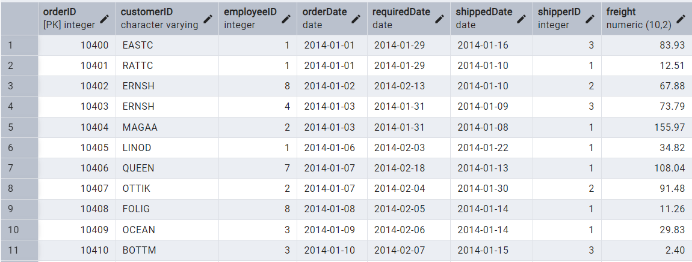=========================================================================

--****4.Filtering****--

--Retrieve the product_id, product_name, and unit_price of products where the unit_price is greater than 15--

SELECT "productID", "productName", "unitPrice"

FROM products

WHERE "unitPrice" > 15;

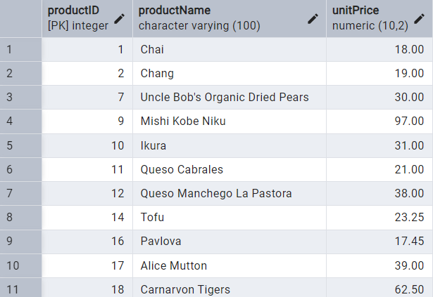

--List all employees who are located in the USA and have the title "Sales Representative"--

SELECT *

FROM employees

WHERE country = 'USA'

AND title = 'Sales Representative';

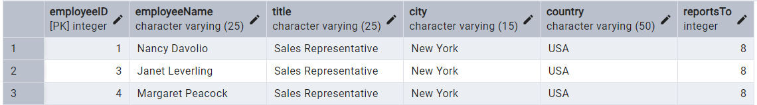

--Retrieve all products that are not discontinued and priced greater than 30--

SELECT *

FROM products

WHERE discontinued = 0

AND "unitPrice" > 30;

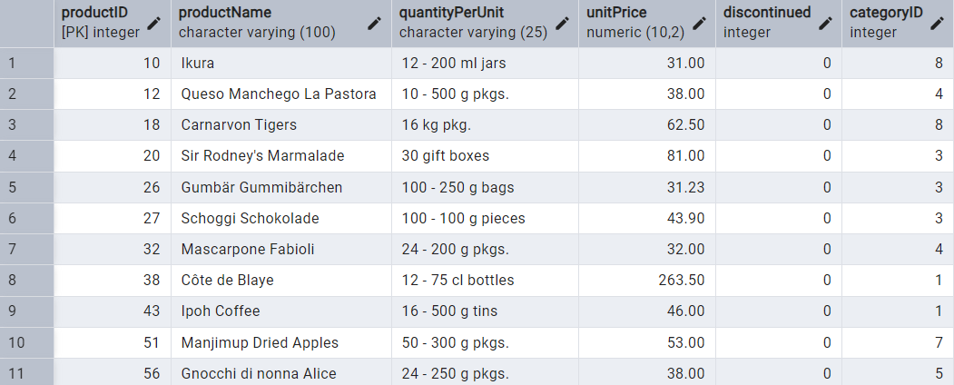=========================================================================

--****5.Limit/Fetch****--

-- Retrieve the first 10 orders from the orders table--

SELECT *

FROM orders

ORDER BY "orderID"

LIMIT 10;

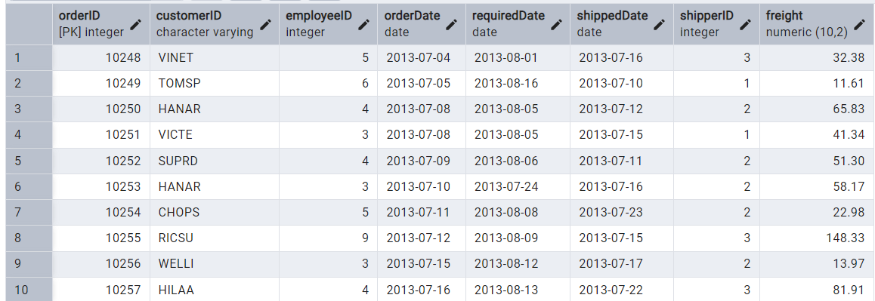

--Retrieve orders starting from the 11th order, fetching 10 rows (i.e., fetch rows 11-20)--

SELECT *

FROM orders

ORDER BY "orderID"

OFFSET 10

LIMIT 10;

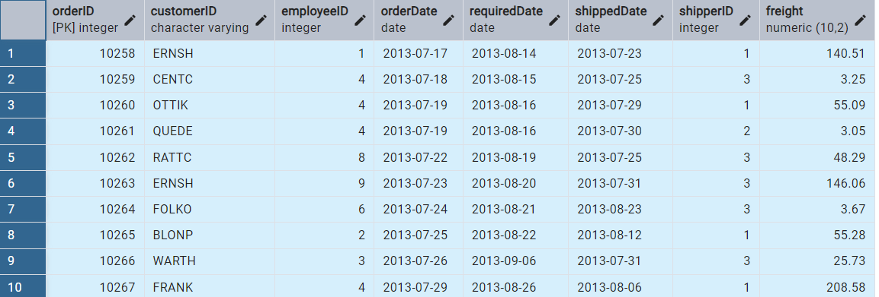

--****6.Filtering (IN, BETWEEN)****--

--List all customers who are either Sales Representative, Owner--

SELECT *

FROM customers

WHERE "contactTitle" IN ('Sales Representative', 'Owner');

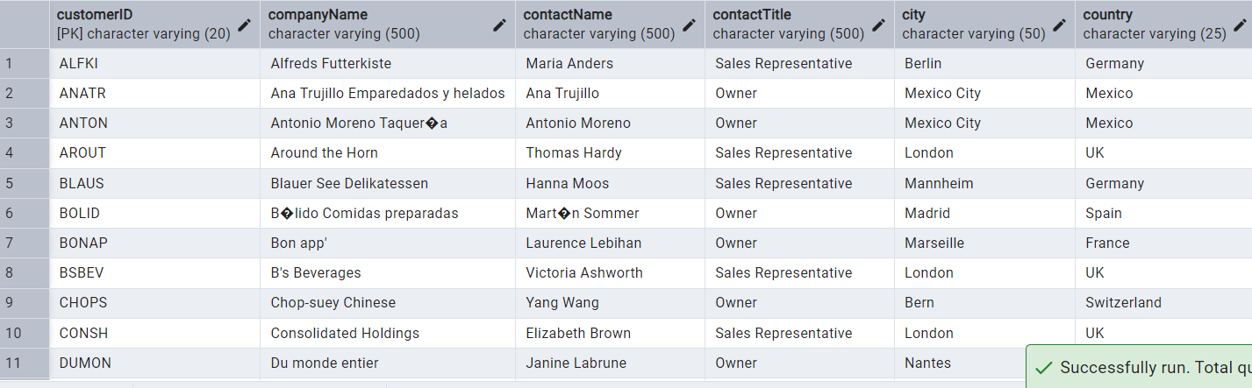

--Retrieve orders placed between January 1, 2013, and December 31, 2013--

SELECT *

FROM orders

WHERE "orderDate" BETWEEN '2013-01-01' AND '2013-12-31';

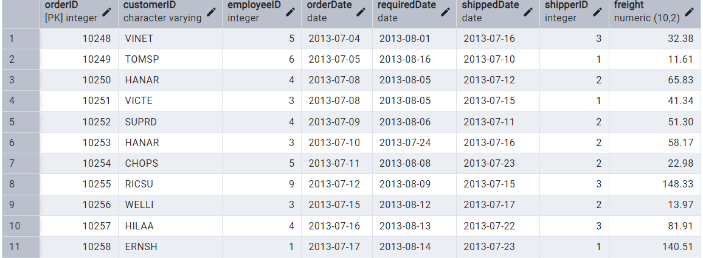=========================================================================

--****7.Filtering****--

--List all products whose category_id is not 1, 2, or 3--

SELECT *

FROM products

WHERE "categoryID" NOT IN (1, 2, 3);

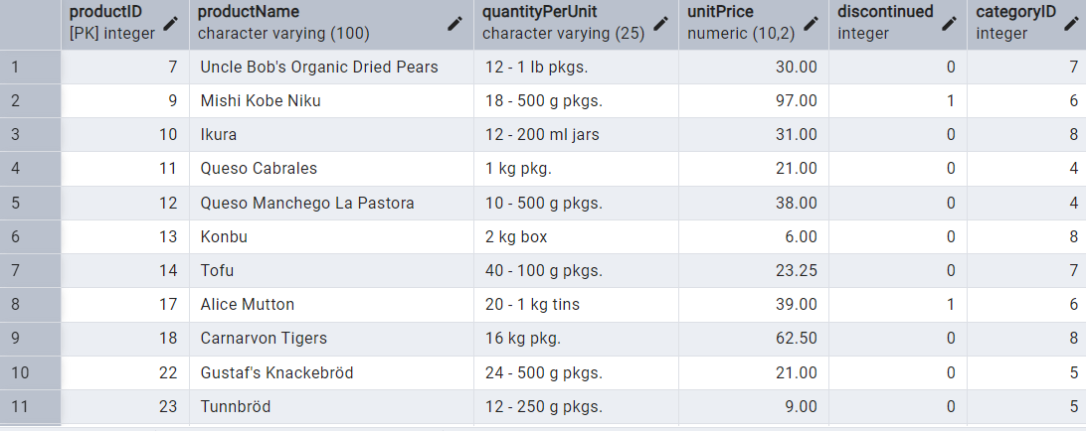

--Find customers whose company name starts with "A"--

SELECT *

FROM customers

WHERE "companyName" LIKE 'A%';

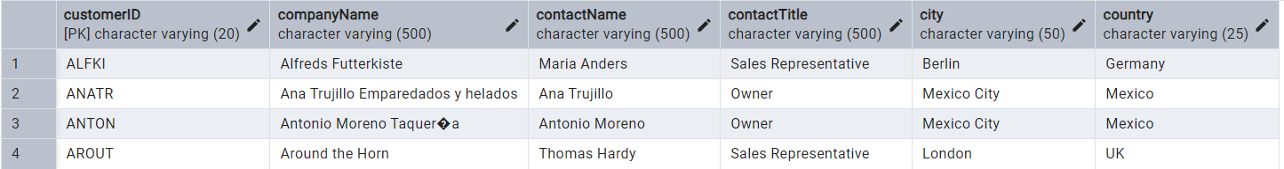=========================================================================

--****8.INSERT into orders table****--

--Adding new order in orders table--

INSERT INTO orders (

"orderID", "customerID", "employeeID", "orderDate",

"requiredDate", "shippedDate", "shipperID", "freight"

)

VALUES (

11078, 'ALFKI', 5, '2025-04-23',

'2025-04-30', '2025-04-25', 2, 45.50

);

select * from orders

  
=========================================================================

--****9.Increase(Update) the unit price of all products in category_id =2 by 10% ****--

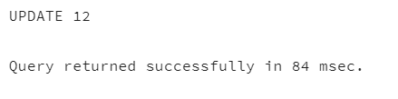UPDATE products

SET "unitPrice" = "unitPrice" * 1.10

WHERE "categoryID" = 2;

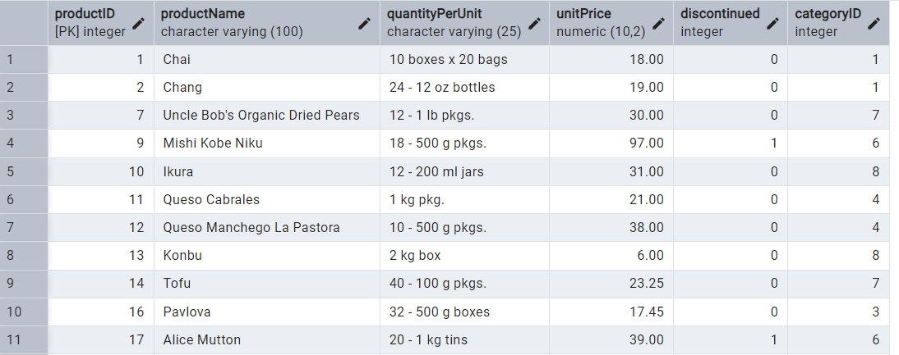

=========================================================================

--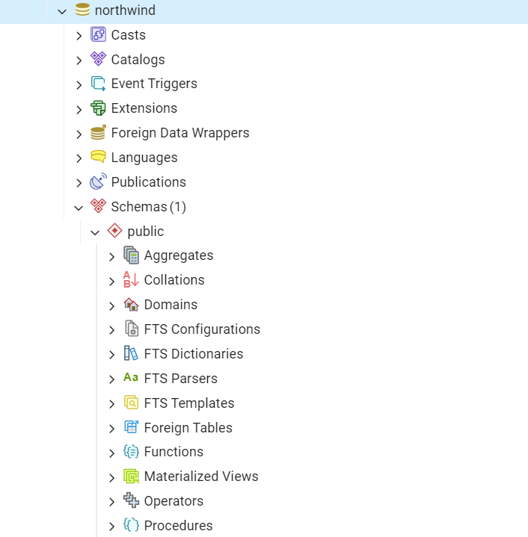****10.Imported northwind database from the given GitHub url****--